130089872

Network Fundamentals By Dale Smallwood

Contents

Table of Figures 3

Introduction 4

Networking Principles 5

Availability 5

Class of service (CoS) 5

Protecting your data 6

Encryption 6

The cloud security principle 8

Public Cloud Security 8

Private Cloud Security 8

Hybrid Cloud Security 8

What is a Wide Area Network? 9

Asynchronous Transfer Mode (ATM) 9

What is a Frame relay? 9

Packet switching 10

Connectionless Packet Switching 10

Connection-Oriented Packet Switching 10

Issues with packet switching 10

Circuit Switching 10

Which method is more efficient? 10

Point to point 10

Why optimizing WAN is important 11

What is an Local area network (LAN) 11

Hardware that is used to create the system 11

Network Interface Card 11

Transmission media 11

Twisted pair cables 11

Coaxial cables 12

Optical fibres 12

The benefits of using LAN 12

Address resolution protocol (ARP) 12

The types of LANs 12

Network connection devices 13

Hub 13

Switch 13

Routing Information Protocol (RIP) 13

Border Gateway Protocol (BGP) 13

Enhanced Interior Gateway Routing Protocol (EIGRP) 14

Open Shortest Path First (OSPF) 14

Conclusion 14

Bibliography 15

Appendix 16

# Table of Figures

Figure 1 Encrypted password (S123) 6

Figure 2 Displayed password (123) 7

Figure 3 Example of frame relay 9

Figure 4 Example of EIGRP protocol 14

# Introduction

Inside this document contains a brief overlook of networking principles and the basic contents of both WAN and LAN networks.

# Networking Principles

The principles of networking are as follows.

### Availability

There are many different elements that contribute to availability. Each of these aspects are the solution to availability. Aspects are as follows:

* Stability looks at design and choice of equipment to ensure that the environment configuration is suitable.
* Monitoring, the network frequently to detect if there are any issues being able to track down the fault effectively.
* Checking for redundancy is key when overlooking the network as sometimes there can be multiple paths between two points that may be unneeded or be efficient enough to maintain during heavy traffic.
* Lifecycle management during the life of the network updates and upgrades may be required. This needs to be done efficiently reducing downtime.

### Class of service (CoS)

(Juniper Networks, 2017)“When a network experiences congestion and delay, some packets must be prioritized to avoid random loss of data.” This process is called Class of Service (CoS). As explained inside the quote, data needs to be prioritised, such as emails, videos, and documents. This principle is used on switches and routers on other devices to configure existing CoS values.

# Protecting your data

No matter how small or large the company is, network protection is one of the most important things to remember when operating on the internet using a LAN or WAN connection. While no network is impenetrable to threats, a reliable and effective network protection infrastructure is critical for safeguarding client data. An effective network management scheme can assist businesses in reducing the risk of data loss and sabotage.

Networks can be protected from malicious spyware thanks to network protection. It also guarantees the safety of shared information. By breaking down information into various bits, encrypting these parts, and sending them across separate routes, network security.

## Encryption

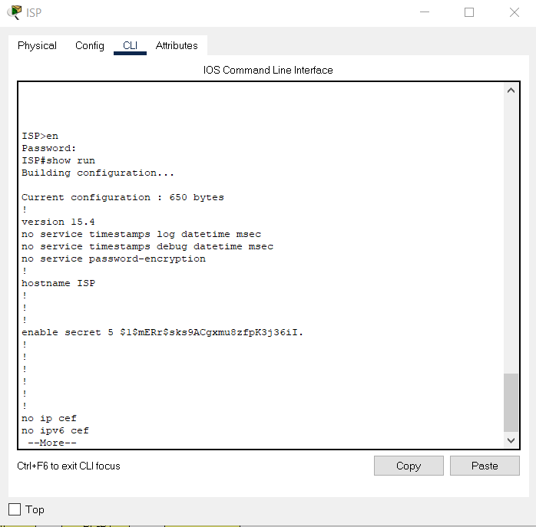Another way of protecting data would be encrypting the information that is being passed through the network. This is done by using the secure sockets layer (Figure1) and (Figure 2) one password is encrypted, and one is not. When this protocol is being used, it can be noticed on a URL of a website as the ‘S’ of HTTPS. This states that the connection is safe and secure. It is normally used when using payment methods or providing sensitive information. (SSLRenewals, 2021) “To give a safer web browsing experience from 2018 onwards, Google has decided to flag the websites which do not have an SSL/TLS Certificate installed on their website.” Failing implement SSL after 2018 all of the world's most common web browsers, such as Google Chrome and Firefox, would. punish them by displaying an error message saying ‘Not Safe' URL bar. (SSLRenewals,2021)

Figure Encrypted password (S123)

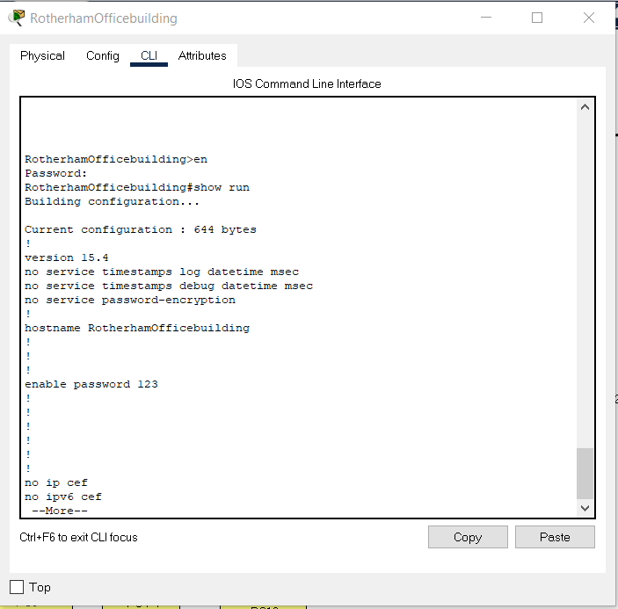

Figure Displayed password (123)

# The cloud security principle

There are many cloud security principles. Below is a brief look into these.

### Public Cloud Security

A third-party cloud service provider is responsible for securing the technology in a public cloud. Advanced data protection measures, such as data encryption, tracking, and access management, are available from the most common services (Google, Amazon Web Services, and Microsoft Azure).

That is not to say that their customers should not be concerned about protection. A mutual responsibility concept is used in public clouds, in which the vendor is responsible for the infrastructure, but the user is also responsible for the security of their own workloads. Customers may also make mistakes by misconfiguring controls, leaving confidential data in vulnerable areas, giving access to the wrong users, or providing too much access to registered users, even if these services have useful protection software.

### Private Cloud Security

A private cloud is a set of resources that are only accessible to a limited number of people, normally the staff of the company that runs it. Users benefit from self-service and remote control, while network providers benefit from elasticity and scalability – with the caveat that bandwidth is reduced to that usable on the network operator's networks. While private clouds are more reliable than public clouds, they do entail the same staffing, administration, and upkeep as a conventional network.

### Hybrid Cloud Security

A hybrid cloud is a combination of public and private networks, as well as on-premises networks. Data, workloads, software, and resources may be exchanged between infrastructures, but confidential data and other essential assets can be kept off the public cloud for extra protection. Cloud bursting is another feature of hybrid cloud, in which demand surges are temporarily met by public cloud services as private cloud resources exceed availability. Hybrid clouds add difficulty, they can also provide increased protection by restricting confidential assets to the private cloud or data centre, while standard workloads can run on the less costly public cloud.

# What is a Wide Area Network?

Wide area networks (WAN) for short are normally used by a business that functions globally, WANs are able to make contact easier between different locations or buildings but can also be used in day-to-day tasks such as navigating the internet WANs are the most large-scale networks currently available these are used by schools, the government and also the general public using a WAN grants the ability to store information and communicate with others, there are multiple ways of accessing this these are known as protocols. (INC, 2020)” WANs are often used by larger corporations or organizations to facilitate the exchange of data, and in a wide variety of industries corporations with facilities at multiple locations have embraced WANs. “

## Asynchronous Transfer Mode (ATM)

(Network Encyclopedia, 2021)“ATM devices do not send and receive information at fixed speeds or using a timer, but instead negotiate transmission speeds based on hardware and information flow reliability. The “transfer mode” in ATM refers to the fixed-size cell structure used for packaging information. “

## What is a Frame relay?

Frame relay is a protocol designed for packet switching (Figure 3). This is mainly used inside WAN links; frame relays can also be used to contain LAN traffic. Frame Relays has been one of the most widely used WAN services. Despite the availability of many advanced technologies such as VPN and ATM. Frame relay continues to dominate and will continue to do so due to its advantage and is cost-effective when compared to other point-to-point WAN services. (wanredundancy, unknown)“The major advantage of using Frame Relay is its cost efficiency when compared to leased lines. Frame relay’s performance is similar to that of point-to-point leased lines, but at a lesser cost for long distances.”

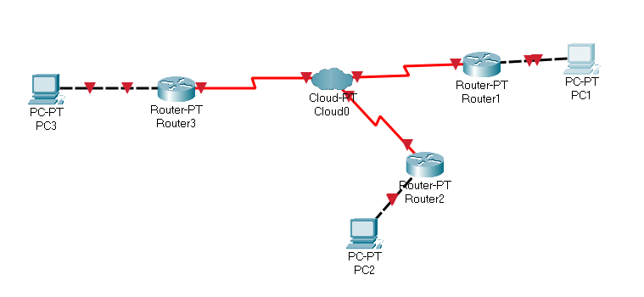

Figure Example of frame relay

## Packet switching

Packet switching is the process of separating a file or information into a shared amount that is being sent from a server to a data centre, then sent to the desired location in small, shared amounts. This is a very efficient way of transferring data as it can be sent through multiple routes of the network. There are two methods of packet switching called **Connectionless and Connection-Oriented.**

### **Connectionless Packet Switching**

This is where packets are sent individually in any order with routing information, such as a source address, destination address., the total number of packets and the sequence number. This is because when all the packets are sent across it is able to be rearrange back together.

### **Connection-Oriented Packet Switching**

Unlike connectionless packet switching, connection-oriented has to be sent in the correct. Original order less information is required doing this method as the files are sent in order.

## Issues with packet switching

Although packet switching is efficient, sometimes it can cause packet loss. This can happen when the data is sent to multiple routers. Before the final location, packet loss can cause congestion inside the network reducing the performance, but there is a way fix this issue using a hop count, which is a way of limiting the maximum times the data can be passed around. Once reaching that maximum amount, the router with that current packet removes the information.

## Circuit Switching

Circuit switching is mainly used for communication methods, such as video and audio. This method is processed before the conversation begins looking for a strong reserved channel that is currently unused. Sometimes two channels are allocated this is called a full duplex, this is different to packet switching as a physical path is created.

## Which method is more efficient?

Comparing packet switching to circuit switching there are many advantages such as efficiency as the packets are able to be sent through multiple gateways unlike circuit switching that would cause bandwidth wastage. Using packet switching is also more cost efficient. (KEARY, 2020)“**Circuit switching and packet switching are undeniably two of the most widely-used techniques for transferring data across enterprise networks.** Both of these two techniques have their own space within modern networking.”

## Point to point

Point to point is having only one path to send the data, it works by having two end nodes inside a WAN network using a leased line. (IBM, 2015)“When each point-to-point connection is defined to your system, a routing entry must be made on each end to describe how to get to any network at the other end of the connection.”

## Why optimizing WAN is important

WAN optimization can grant so many benefits and improvements to a business such as, being able to access files faster, improves performance, faster data recovery, drastically reduce the cost of the bandwidth expenses. But why is it needed? (Mareco, 2012)“major trends are driving more and more traffic over the WAN which will have a major impact specifically on the performance of business-critical applications that cross the WAN. “

# What is an Local area network (LAN)

A local area network or know as LAN, is a device that can connect to web servers and internal servers. As well as access points and switches routers and other components. Businesses use this to stay in contact with other parts of the network as all devices would be on the same network, so all employees can access the system wherever needed.

## Hardware that is used to create the system

When connecting an electronic device to a local area network (LAN), a number of different hardware components are needed such as a Network interface card and transmission media.

### Network Interface Card

A network interface card (NIC) is a piece of hardware that allows a device to link to a network. It is a circuit board that is inserted in a computer and provides the computer with a dedicated network link (DNI). It is also known as a network adapter, network interface controller, or LAN adapter. But what does it do? Both wired and wireless connections are possible with the NIC. The network interface card NIC enables communication between computers connected by a LAN as well as communication over a large-scale network using the IP. A NIC is a physical layer and data link layer unit that provides the required hardware circuitry for physical layer and certain data link layer processes to operate on it.

### Transmission media

There are three types of transmission, twisted pair cables, coaxial cables, and optical fibres. They are used to send data via a physical connection. Below is an explanation of each one.

### Twisted pair cables

Twisted pair cables were created in 1881 by Alexander Graham Bell and were implemented into the American telephone network and is still used to this day. Twisted pair cables are designed to transmit data in circuit with reduced crosstalk. (launcheditor, 2019)“A twisted pair cable is created by taking two different insulated wires and twisting them together, allowing them to run parallel to each other in a pattern.” Pros of using twisted pair cable are as follows, it is extremely light cost efficient and flexible and a simple implementation. As well as this, the data is able to be transferred faster than coaxial cables.

### Coaxial cables

Coaxial cable contain copper is a conductor that has an outer layer of plastic and a conducting shield. They are commonly used for providing a dedicated bandwidth and also distributing cable bandwidth. This is used but a lot of broadband providers use coaxial cables as it can provide high speed connections. But the major downside of used coaxial cables is they carry less bandwidth of twisted pair cables and optical fibres and more likely to be struck by lightning (MARTINEZ, 2018) “the sensitive integrated circuits are easily damaged by remnant transient voltage surges.”

### Optical fibres

Optical fibres are thin rods of glass with a plastic cover which uses light waves to transfer data. They can be used for audio data as well as video the downside to using optical fibres is it can be very costly for implementation and can be difficult to maintain so it might be recommended to see if using optical fibres is efficient for your location and business. A plus side to optical fibres they can provided high speed connections and are very secure. (Collins, 2019)“The only way to penetrate fiber-optic Internet is to physically cut the fibers, which will cause the signal to disappear. Fiber-optic Internet is one powerful way to increase your company's protection against cyber crime.”

## The benefits of using LAN

As touched on previously, all devices are connected to the same network this makes it easier to print out documents, communicate between computers and sharing files. Although this was discovered LANs were not as popular and used frequently till the deployment of WI-FI now LANs are used inside almost every sort of environment from businesses and schools to homes, now that WI-FI is introduced connecting to a LAN is extremely easy with almost any device.

## Address resolution protocol (ARP)

An ARP is used to connect IP addresses to MAC Address. To connect, the Mac address is needed to connect to a LAN. A Mac address is made up of numbers and letter to create a unique code and is assigned to a NIC. An example of an MAC address is as follows: 00-04-5A-63-AI-66. This code is used to determine which devices is being connected to. You can check if your device has had a previous connection with another device through the ARP Cache. If this information is empty, the computer will ask all computers, with the same IP address for MAC address. The computer with the matching IP address with them responds back with their MAC address, once this is completed the information is stored into the ARP Cache. This makes the network more efficient as process will not be repeated as the information is already stored.

## The types of LANs

There are two types of LANs known as server LANs and peer to peer LANs, a server LAN has several devices connected to a central serve, (Cisco , 2020)” The server manages file storage, application access, device access, and network traffic.”

## Network connection devices

There are many forms of equipment used when building a network bellow is an explanation of each commonly used piece of equipment.

## Hub

A hub / ethernet hub are used when connecting more than one computer to the same network purely using cables, using hubs can also maintain a stable connection over a longer distance. Unlike using routers, hubs are used inside LAN networks a downside to this equipment is that (melnick, 2019)“Hubs do not perform packet filtering or addressing functions; they just send data packets to all connected devices. Hubs operate at the Physical layer of the Open Systems Interconnection (OSI) model. “due to these limitations hubs are rarely used now and are replaced by switches this is because hubs contain less ports, provide a maximum of 10Mb and are only able to transmit at half duplex. Unlike a switch that is 10Mb to 1Gb and is able to have more ports and transmit at half and full duplex.

## Switch

Switches can sometimes look similar to hubs but function in a more advanced manner and also work on the second OSI layer known as the data link layer. Switches are able to improve efficiency of the network whilst having multiple connections doing so also limits the routing information. As well as this, unlike hubs switches are able to read packets and send to the correct destination, using a switch is more efficient than hubs and routers and also improve network security a downside to using switch is (melnick, 2019) Switches can be subject to distributed denial of service (DDoS) attacks; flood guards are used to prevent malicious traffic from bringing the switch to a halt. “

## Routing Information Protocol (RIP)

When building networks, there are many routers the information can take. These different routes are given a protocol name. This one is named RIP. RIP is used to decide what route a packet should take to get to its end point. The RIP protocol used a routing table. This is a list of rules that assist on deciding the path. The information is updated every 30 seconds to the closest router if they are connected to the same network. Rips are quite easy to understand and can implemented on nearly all routers, but the bandwidth will be inefficient and is not feasible on large networks as it can cause convergence.

## Border Gateway Protocol (BGP)

The BGP is very similar to a GPS system. This is because it looks for the most efficient route for each time it sends a packet. An issue with using BGP is there is no authentication, (Sadeta Krijestorac, 2011)“BGP has been found to be vulnerable to attacks and misconfigurations. The cause of this problem is that BGP depends on information to update routing tables that is difficult to verify” but are able to be used to setup flexible connections so when using an BGP the network could be act risk.

## Enhanced Interior Gateway Routing Protocol (EIGRP)

The EIGRP has the same targets as RIP and BGP but the process is displayed differently as it passes the information across one router at a time and only focuses on that path first. Once the information reaches that router, then it will send this information. Routers that are behind this to explain this in more detail let’s look at (Figure4) as shown. Router B wants to the information to reach Router H. But first it needs to check what the best connection is between C, D and E. Once that it is determined that route will be taken and send back to Router A. After this, the process is repeated till reaching the destination. The advantage of using EIGRP does not use a lot of the network resources and can be very efficient, but the issue with using EIGRP is it can only be used on cisco networks.

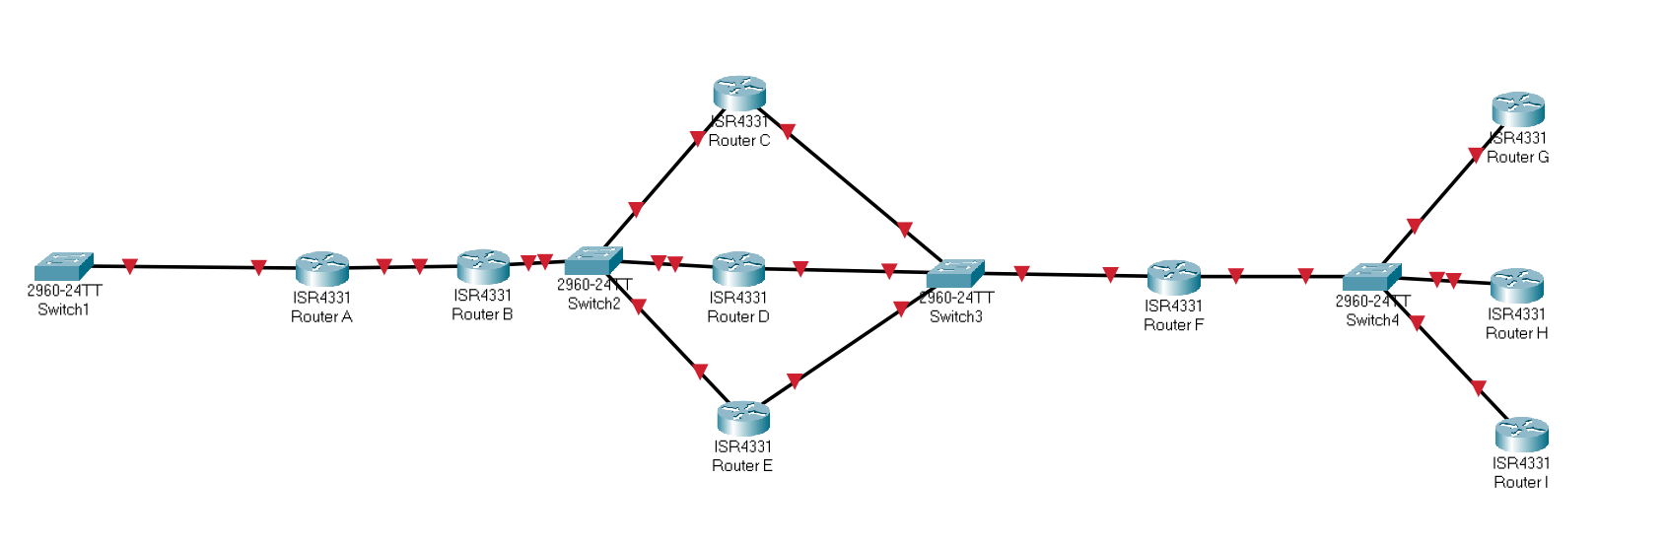

Figure Example of EIGRP protocol

## Open Shortest Path First (OSPF)

Open shortest path first or known as (OSPF) is networking protocol used to find the shortest distance between router to router to send packets. It looks at a verity of paths to find out the best option, but the way this is achieved is very similar to EIGRP but is able to be used in almost any network. It is also supported inside IPv4 and IPv6 networks. OSPF has unlimited hop counts and EIGRP is limited to how many hops can be used. Therefore, this is a more efficient protocol for large scale builds and also has a fast convergence time. A downside to using OSPF is that the routing information is duplicated, generating an extra amount of memory being used, which can lead to the network being very intensive on the processor.

# Conclusion

In conclusion, OSPF is one of the best protocols currently available. It is important to understand and should be used inside future builds depending on the requirements. This was discovered by justifying and comparing the features available between multiple networking protocols such as RIP, BGP, and EIGRP this can be demonstrated the build provided.

# Bibliography

Cisco . (2020). *What Is a LAN?* Retrieved from Cisco: https://www.cisco.com/c/en/us/products/switches/what-is-a-lan-local-area-network.html

Collins, T. (2019, December 11th). *11 Huge Business Benefits of Fiber Internet Connectivity*. Retrieved from Atlantech online: https://www.atlantech.net/blog/11-huge-business-benefits-of-fiber-internet-connectivity

IBM. (2015). *Routing with point-to-point connections*. Retrieved from IBM Documentation: https://www.ibm.com/docs/en/i/7.3?topic=methods-routing-point-point-connections

Juniper Networks. (2017, September 20th). *Understanding Class of Service (CoS) Profiles*. Retrieved from TechLibrary : https://www.juniper.net/documentation/en_US/junos-space-apps/connectivity-services-director3.0/topics/concept/cos-profile-understanding-csd.html

KEARY, T. (2020, June 26th). *Circuit Switching vs Packet Switching: Differences, Advantages & Disadvantages*. Retrieved from Comparitech: https://www.comparitech.com/net-admin/circuit-switching-vs-packet-switching/

launcheditor. (2019, jan 20th). *What is a Twisted Pair Cable?* Retrieved from Gateway Cable Company : https://www.tgccompany.com/what-is-a-twisted-pair-cable/

Mareco, D. (2012, July 12th). *WAN Optimization: What is it and what are the benefits?* Retrieved from secure edge: https://www.securedgenetworks.com/blog/wan-optimization-what-is-it-and-what-are-the-benefits

MARTINEZ, M. (2018, April 5th). *Modern Coaxial and Ethernet Interconnect Surge Protection*. Retrieved from agl media group: https://www.aglmediagroup.com/modern-coaxial-and-ethernet-interconnect-surge-protection/

Network Encyclopedia. (2021). *Asynchronous Transfer Mode (ATM)*. Retrieved from networkencyclopedia: https://networkencyclopedia.com/asynchronous-transfer-mode-atm/

SSLRenewals. (2021). *Why is SSL Important? Benefits of Using an SSL Certificate*. Retrieved from sslrenewals: https://sslrenewals.com/blog/why-is-ssl-important-benefits-of-using-ssl-certificate

wanredundancy. (unknown). *Frame Relay*. Retrieved from wanredundancy: https://www.wanredundancy.com/frame-relay.html

## Appendix

#### Maintenance schedule

|  |  |  |  |  |
| --- | --- | --- | --- | --- |
| Task | Daily | Weekly | Monthly | Quarterly |
| Clear temporary internet cache | X |  |  |  |
| Clear temporary windows cache | X |  |  |  |
| Clear temporary ARP |  | X |  |  |
| Check for latency and utilisation | X |  |  |  |
| Check for viruses using anti-virus software | X |  |  |  |
| Check for general software updates |  | X |  |  |
| Back up data | X |  |  |  |
| Check for data breaches | X |  |  |  |
| Inventory count of equipment | X |  |  |  |
| Clean equipment (dusting) |  |  | X |  |
| Stress test equipment |  |  | X |  |
| Physically check equipment is functioning | X |  |  |  |
| Breakdown of bandwidth usage |  |  | X |  |
| Check backup storage / remove outdates files |  | X |  |  |
| Restart server |  |  | X |  |
| Check security log for breaches on the server |  |  | X |  |
| Update equipment |  |  |  | X |
| Clear unneeded user data / inactive users |  |  | X |  |

#### Test log

|  |  |  |  |  |  |  |
| --- | --- | --- | --- | --- | --- | --- |
| Test number | Date & time of test | Test title and brief description | Expected result | Result | Pass or fail? | Notes |
| 1 | 04/05/2021  9:30 | Ping from router ISP to Rotherham server | All 4 packets to be received | All 4 packets sent and all 4 were received | Pass | Test was successful,  this test was conducted to see if information is sent correctly. |
| 2 | 04/05/2021  9:31 | Is ISP router password encrypted? | Router password to be encrypted | Router password is encrypted with numbers | Pass | Test was successful, this test was conducted to check there is some level of security. |
| 3 | 04/05/2021  9:32 | Is OSPF implemented on ISP router | For ‘show ip ospf route’ to display the ospf path | When inputting “show ip ospf route” no information was displayed after | Fail | This test was unsuccessful and will need to be resolved and tested again. |
| 4 | 04/05/2021  9:56 | Input ‘show run’ on ISP router to find out if there is any sign of OSPF implementation | Router information to be displayed | Router information was displayed including OSPF implementation but on the wrong ip address | Pass | Doing this test discovered that there was an attempt of adding OSPF to the network but was done incorrectly. |
| 5 | 04/05/2021  10:46 | Second check of if OSPF implement on the ISP router | OSPF path is now displayed | OSPF path is now displayed and updated to correct corresponding network | Pass | The issue was resolved by updating the ospf ip list. |
| 6 | 04/05/2021  11:42 | Ping from Rotherham server room to ISP | All packets to be received | All packets received | Pass | This shows that information can be sent from ISP and Rotherham server room without issue |
| 7 | 04/05/2021  12:39 | Is ospf implemented on Rotherham server room | For an ospf path to be displayed | When typing show ip ospf route, nothing is displayed. | Fail | As well as this “ospf-5-adjchg: process 1” keeps displaying |
| 8 | 06/05/2021  13:24 | Resolving the “ospf-5-adjchg: process 1” issue | When inputting **show ip ospf neighbour information to be displayed of both existing ospf routes** | Both ospf routes are displayed but the deadtimes are different one displays 0:33 and the other 0:36 | Pass | To resolve the issue above no ip routing was inputted and recreating the ospf paths was put in place |
| 9 | 06/05/2021  14:02 | Second test of is ospf implemented on to Rotherham server room | Ospf routing information to be displayed | Ospf routing is now displayed | Pass | The issue was the sub mask was adjusted but not updated |
| 10 | 06/05/2021  14:05 | Ping server from the Rotherham server room router | All packets to be received | All packets received | Pass | As ospf has been added correctly and server ip has been updated the path has been configured |
| 11 | 07/05/2021  11:57 | Have all VLANS been created on switch one? | When inputting show vlan brief it displays all added vlans | All vlans displayed | Pass | All required vlans have been added to the network |
| 12 | 07/052021  12:00 | Has EtherChannel 1 between switch 1 and switch 2 been created | EtherChannel 1 to be connected | EtherChannel was not connected | Fail | When looking at the group the wrong ports were used as a port from switch 1 fa0/1 and switch 2 fa0/2 instead of switch 1 fa0/1 and switch 1 fa0/2 this needs to be updated |
| 13 | 07/05/2021  12:05 | Attempt 2 has EtherChannel 1 between switch 1 and switch 2 been created | EtherChannel 1 to now be connected correctly | EtherChannel1 is now updated correctly | Pass | This issue was solved after noticing that when creating EtherChannel’s the ports inputted need to be on the same switch then inputted on the corresponding switch |
| 14 | 07/05/2021  12:33 | Has EtherChannel2 between switch 1 and switch 3 been created | EtherChannel 2 to be connected | EtherChannel 2 is connected | Pass | Ports 0/23 and 0/24 were used for this channel |
| 15 | 07/05/2021  12:37 | Has EtherChannel3 between switch 3 and switch 7 been created | EtherChannel 3 to be connected | EtherChannel 3 is connected | Pass | Ports 0/21 and 0/22 is used for this channel |
| 16 | 07/05/2021  12:40 | Has EtherChannel4 between switch 2 and 5 been created | EtherChannel 4 to be connected | EtherChannel 4 is connected | Pass | Ports used for channel 4 is 0/23 and 0/24 |
| 17 | 07/05/2021  13:00 | Has EtherChannel5 between switch 3 and switch 5 been created | EtherChannel 5 to be connected | EtherChannel 5 did not exist | Fail | The channel will need to be looked at / recreated before progressing |
| 18 | 07/05/2021  13:08 | Has a trunk been created on switch 5 for group 5 | Trunk to be active | Trunk is not active | Fail | When viewing interface trunk only group 4 is active |
| 19 | 07/05/2021  13:10 | Attempt 2 has trunk been created on switch 5 for group 5 | Trunk to be active | Trunk is active | Pass | Issue was found where the ether channel 5 was not active so to fix this issue channel5 was recreated. |

#### IP Subnetting and Addressing Scheme

|  |  |  |  |  |  |  |
| --- | --- | --- | --- | --- | --- | --- |
| Network | Port | Ip address | Public or Private | Sub mask | First available host | Last available host |
| Rotherham server | Fa0/0 | 192.168.3.100 | Public | 255.255.255.0 | 192.168.3.1 | 192.168.3.254 |
| Rotherham server room | GIG0/0/1 | 192.168.3.1 | Public | 255.255.255.0 | 192.168.3.0 | 192.168.3.255 |
| Rotherham server room | GIG0/0/0 | 11.0.0.2 | Private | 255.255.255.252 | 11.0.0.0 | 11.0.0.3 |
| ISP | GIG0/0/1 | 10.0.0.1 | Private | 255.255.255.252 | 10.0.0.0 | 10.0.0.3 |
| ISP | GIG0/0/0 | 11.0.0.1 | Private | 255.255.255.252 | 11.0.0.0 | 11.0.0.3 |
| Rotherham office building | GIG0/0/0 | 10.0.0.1 | Private | 255.255.255.252 | 10.0.0.0 | 10.0.0.3 |
| Rotherham office building | GIG0/0/1 | 192.168.3.1 | Public | 255.255.255.0 | 192.168.3.0 | 192.168.3.255 |
| Rotherham office building | GIG0/0/1 | 192.168.3.1 | Public | 255.255.255.0 | 192.168.3.0 | 192.168.3.255 |
| Rotherham office building | GIG0/0/1.10 | 192.168.10.3 | Public | 255.255.255.0 | 192.168.10.0 | 192.168.10.255 |
| Rotherham office building | GIG0/0/1.20 | 192.168.20.3 | Public | 255.255.255.0 | 192.168.20.0 | 192.168.20.255 |
| Rotherham office building | GIG0/0/1.30 | 192.168.30.3 | Public | 255.255.255.0 | 192.168.30.0 | 192.168.30.255 |
| Rotherham office building | GIG0/0/1.40 | 192.168.40.3 | Public | 255.255.255.0 | 192.168.40.0 | 192.168.40.255 |
| Rotherham office building | GIG0/0/1.50 | 192.168.50.3 | Public | 255.255.255.0 | 192.168.50.0 | 192.168.50.255 |
| Rotherham office building | GIG0/0/1.60 | 192.168.60.3 | Public | 255.255.255.0 | 192.168.60.0 | 192.168.60.255 |
| Rotherham office building | GIG0/0/1.70 | 192.168.70.1 | Public | 255.255.255.0 | 192.168.70.0 | 192.168.70.255 |